**DAILY ONLINE ACTIVITIES SUMMARY**

|  |  |  |  |  |  |  |  |  |
| --- | --- | --- | --- | --- | --- | --- | --- | --- |
| **Date:** | **20/07/2020** | | | | | **Name:** | **VANDANA** | |
| **Sem & Sec** | **IV sem & B section** | | | | | **USN:** | **4AL18CS095** | |
| **Online Test Summary** | | | | | | | | |
| **Subject** | | **Complex Analysis, Probability and Statistical Methods** | | | | | | |
| **Max. Marks** | | **30** | | **Score** | | | **-** | |
| **Certification Course Summary** | | | | | | | | |
| **Course** | **Predictive Modelling and Analytics** | | | | | | | |
| **Certificate Provider** | | | **Greatlearning academy** | | **Duration** | | | **5.5 hours** |
| **Coding Challenges** | | | | | | | | |
| **Problem Statement1:------------------** | | | | | | | | |
| **Status: ----------------** | | | | | | | | |
| **Uploaded the report in Github** | | | | | **--------------** | | | |
| **If yes Repository name** | | | | | **----------------** | | | |
| **Uploaded the report in slack** | | | | | **YES** | | | |

**Online Test Summary: Today 18MAT41 Descriptive test was conducted there were three questions the test was from 9:30am to 10:15am.Scores not received.**

**Online Certification Course Summary: Today I have completed the course Predictive Modelling and Analytics by attempting the quiz,**

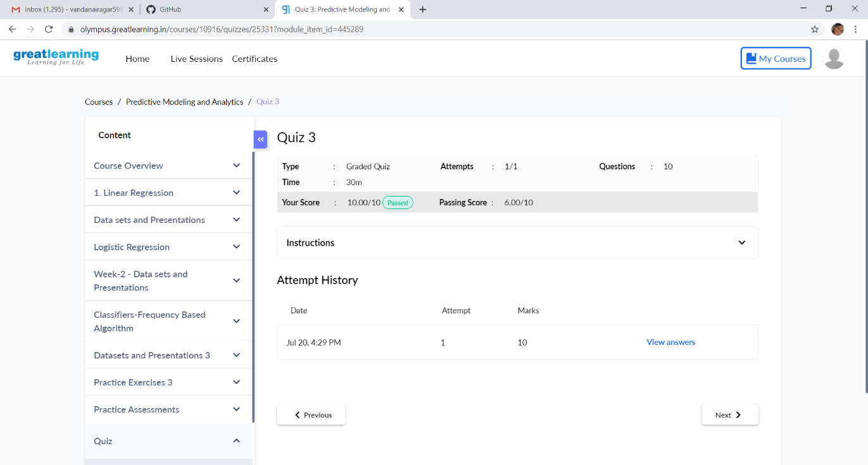

**This is the snapshot of the grades obtained after attempting the quiz.**

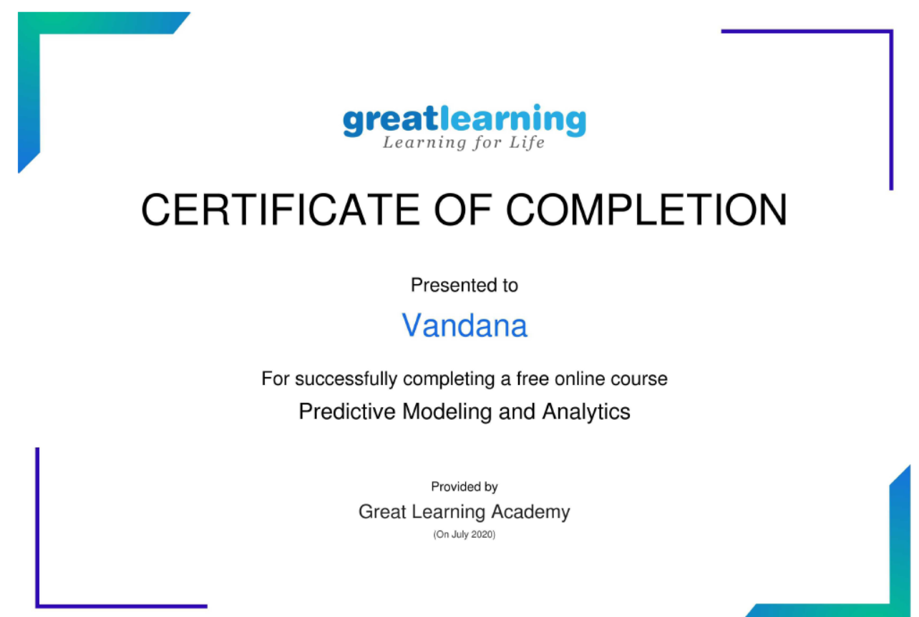

**This is the snapshot of completion certificate obtained after completing the quiz.**

**Online Coding Summary: No problem statements were given.**